
NAME: VICTOR MWANGI
ADM NO: BSCCS/2024/53087
COURSE: BACHELOR OF SCIENCE IN COMPUTER SCIENCE
UNIT CODE: BIT4138
UNIT NAME: ETHICAL HACKING AND COUNTER MEASURES

LECTURER: NYORO MICHAEL

Table of Contents
Verifying the install 3
Basic Scan 3
Port Scanning 4
Footprint Scan 5
INFORMATION GATHERING AND RECONNAISSANCE 6
IP Address & Technologies 6
Domain Registrar 6
Email Patterns 8
SCANNING AND ENUMERATION 9
Port and Service Scan 9
OS Identification & Shared Folders 10
Sub domain 11

Verifying the install
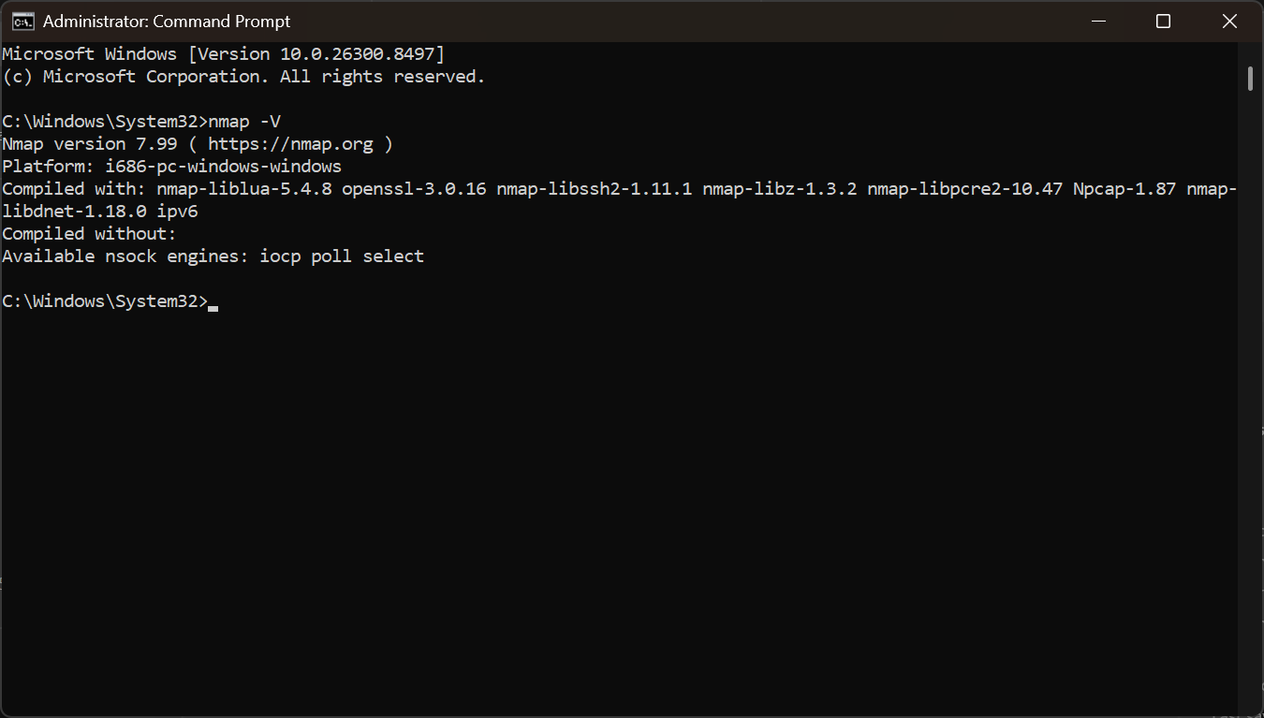
Fig 1: The verification process of nmap

Basic Scan
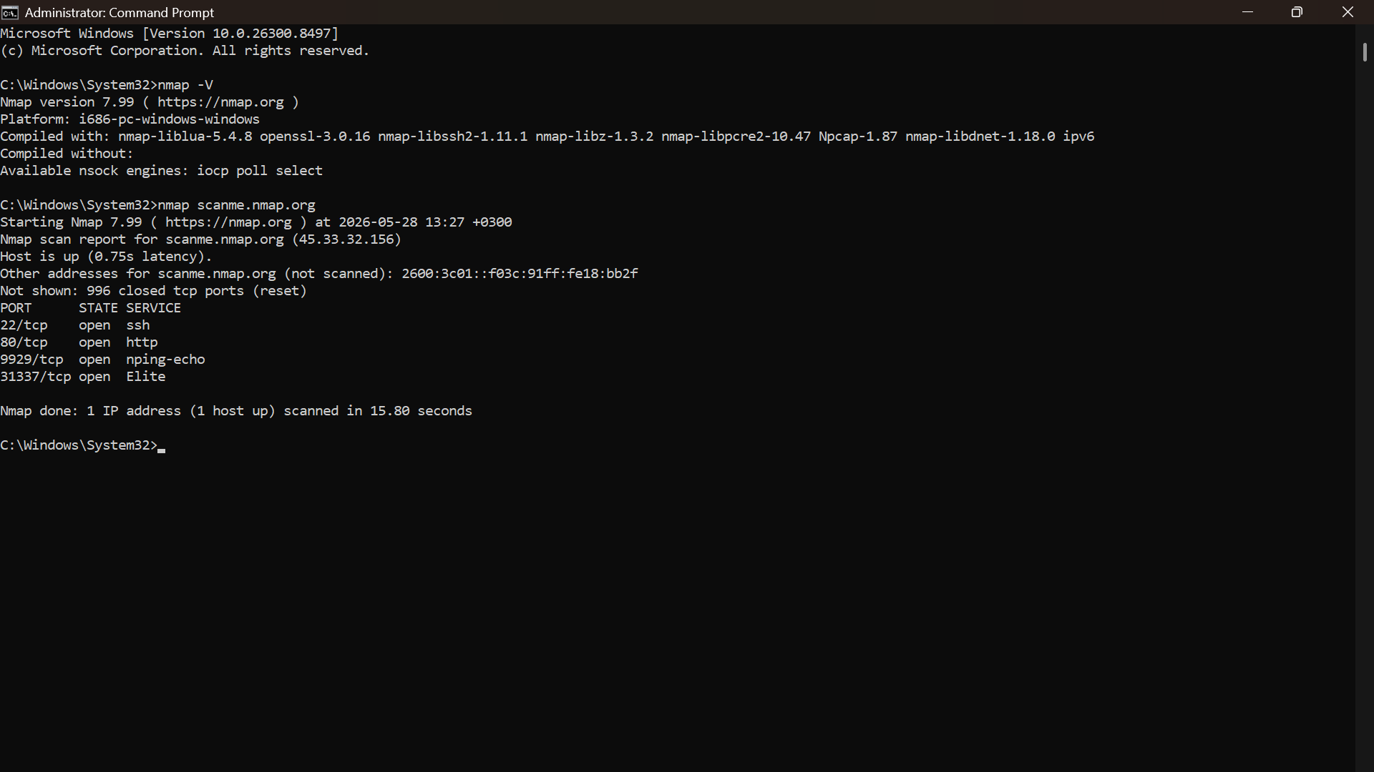
Fig 2: The basic scan
Port Scanning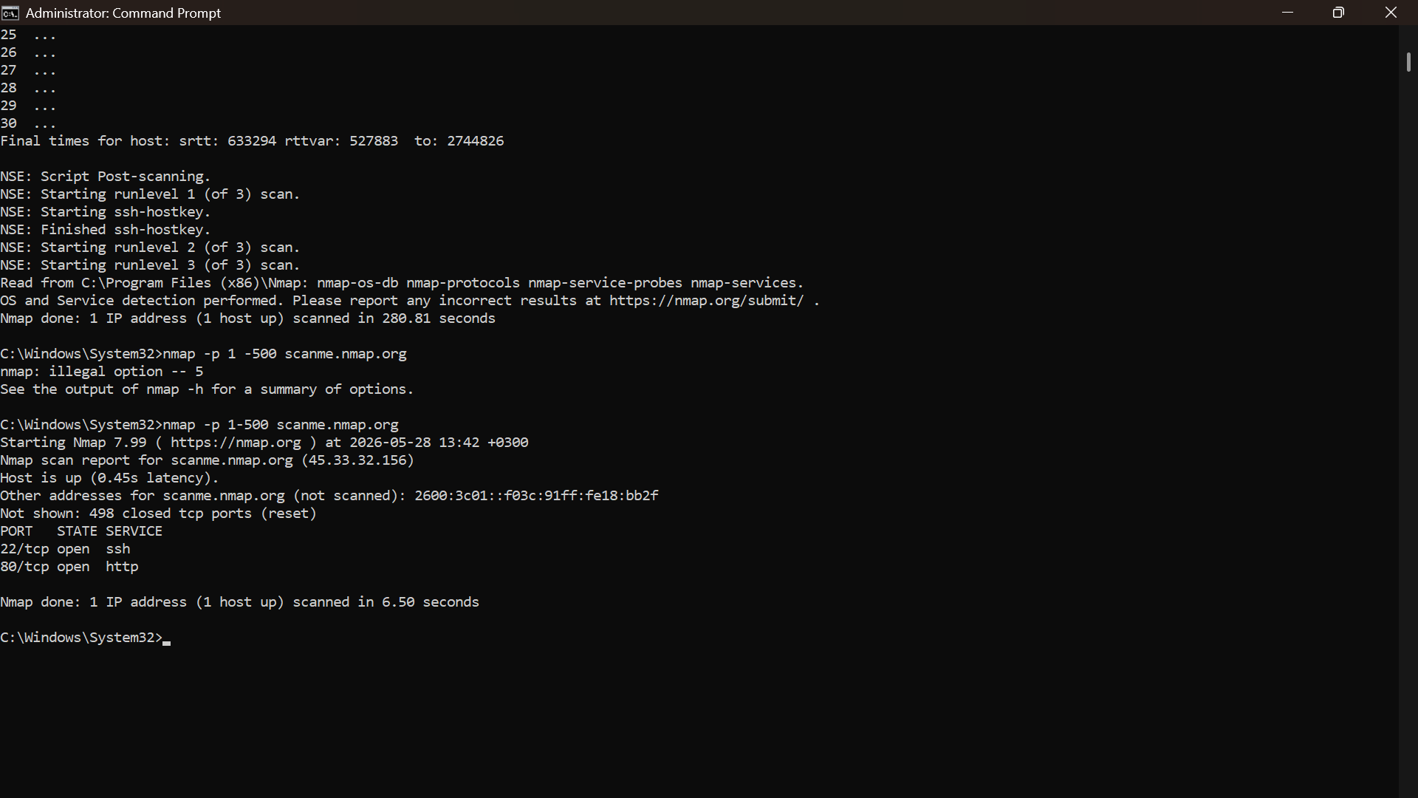
Fig 3: The scanning of ports

Footprint Scan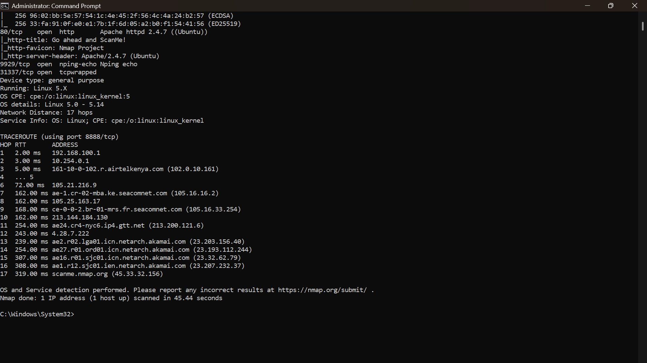
Fig 4: The footprint scan

INFORMATION GATHERING

IP Address & Technologies
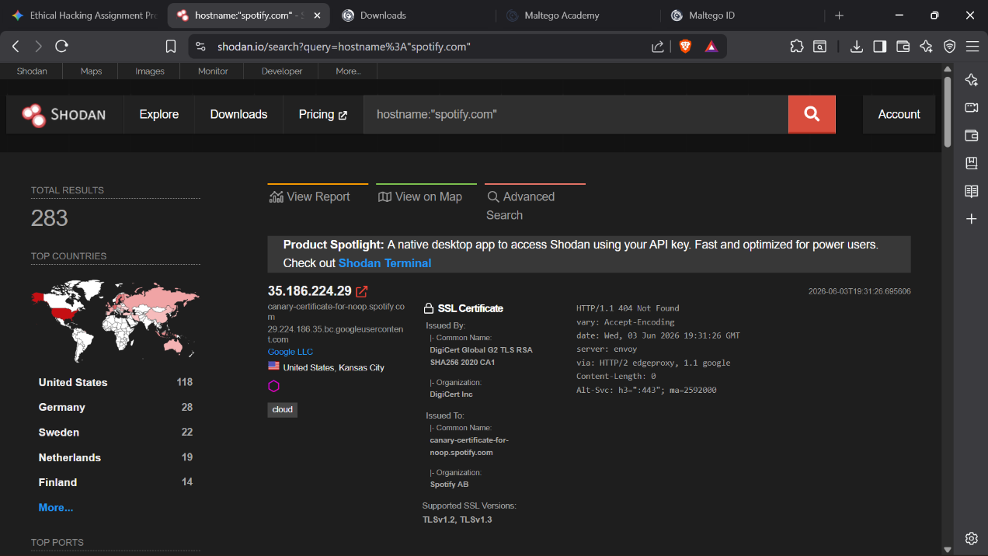
Fig 5: The Shodan website screenshot showing 35.186.224.29, Envoy, and the SSL cert

Domain Registrar
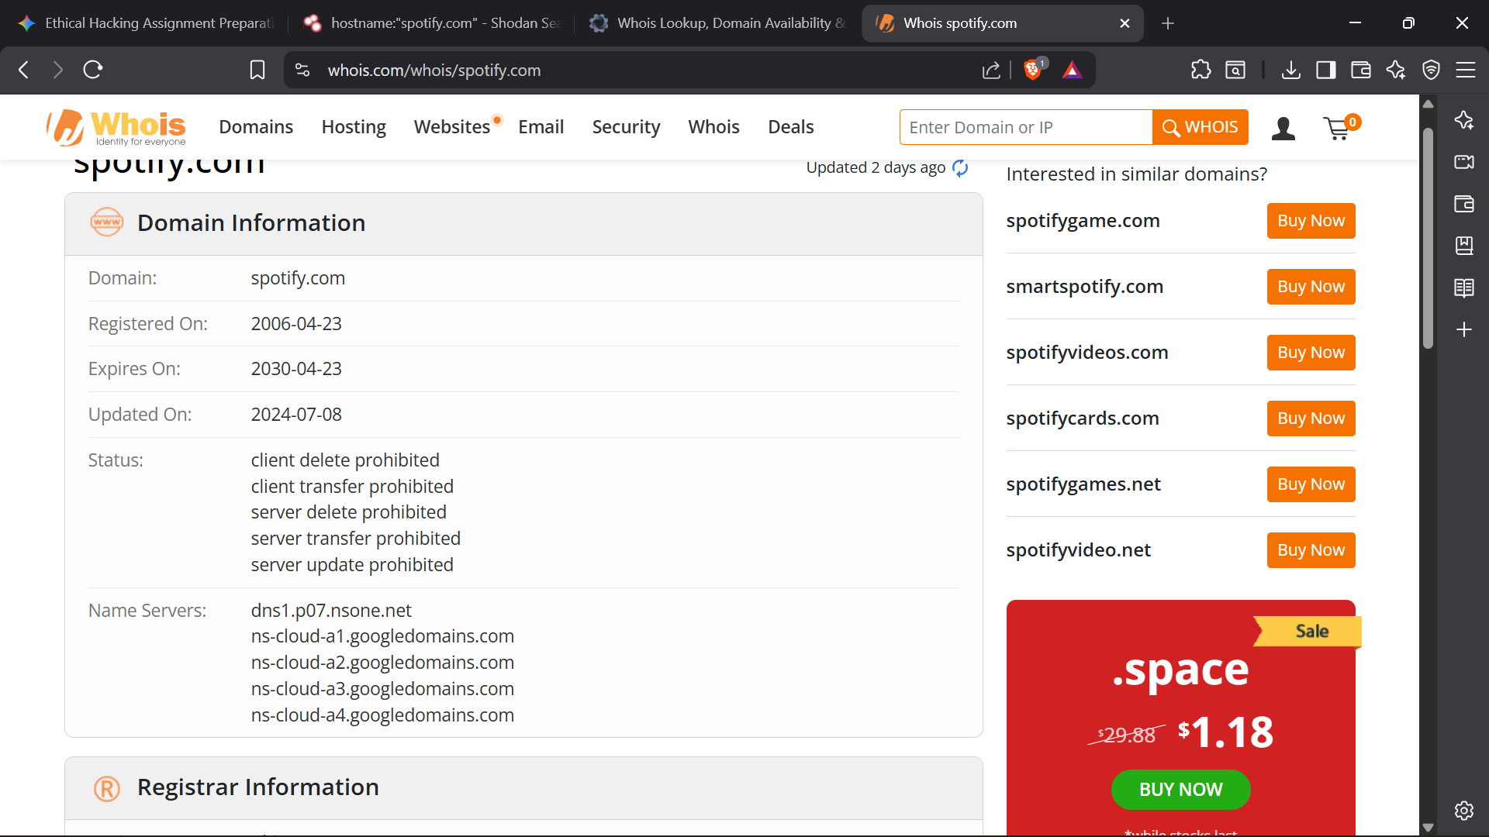
Fig 6: the registrar for the target domain.


Fig 7: the registrar for the target domain.

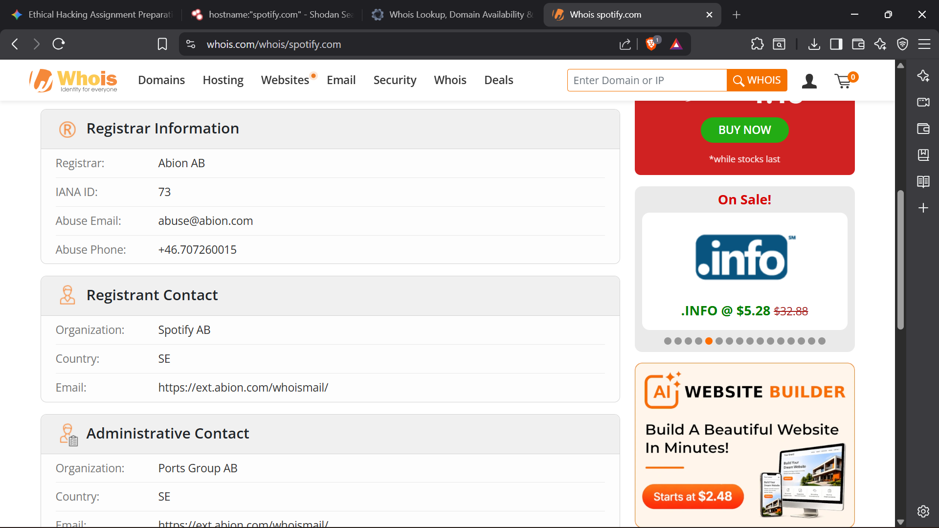
Fig 8: the registrar for the target domain.

Email Patterns
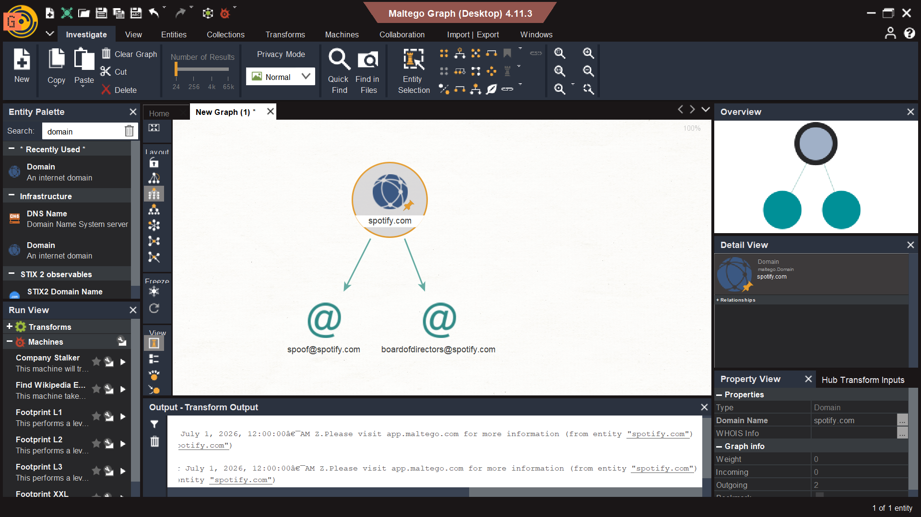Fig 9: Email patterns discovery via maltego

SCANNING AND ENUMERATION

Port and Service Scan
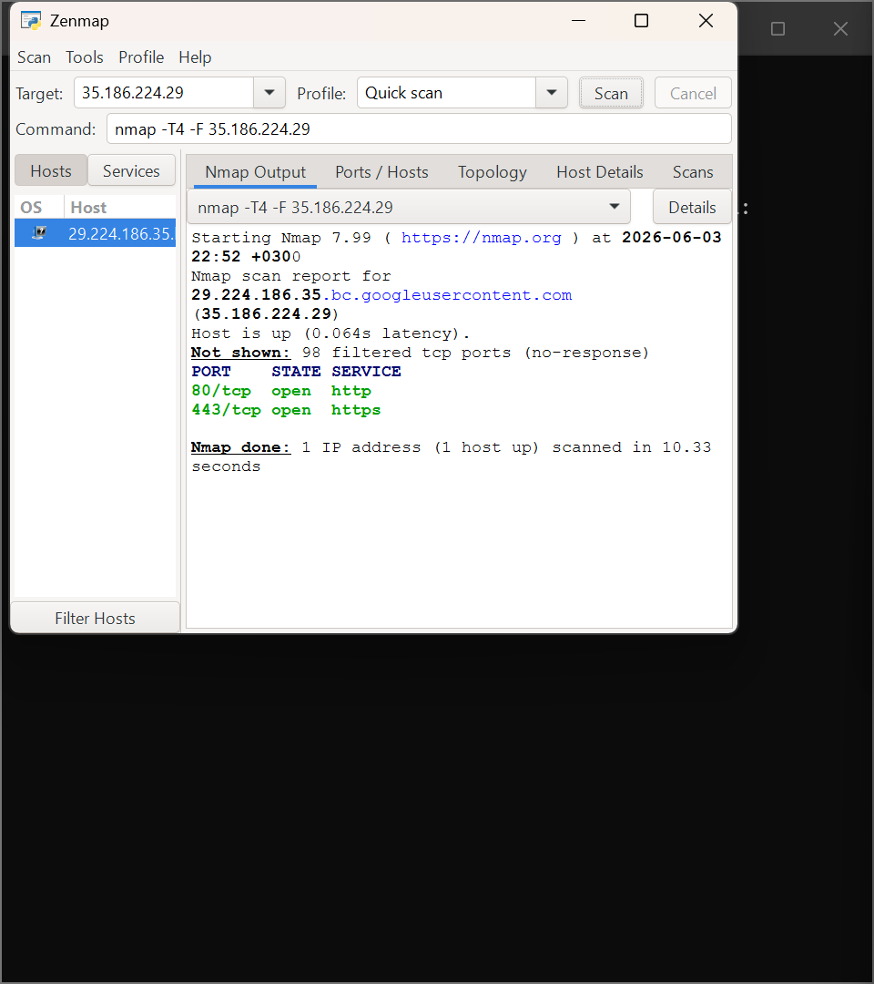
Fig 10: The Zenmap intense scan of 35.186.224.29 showing ports 80 and 443

OS Identification & Shared Folders
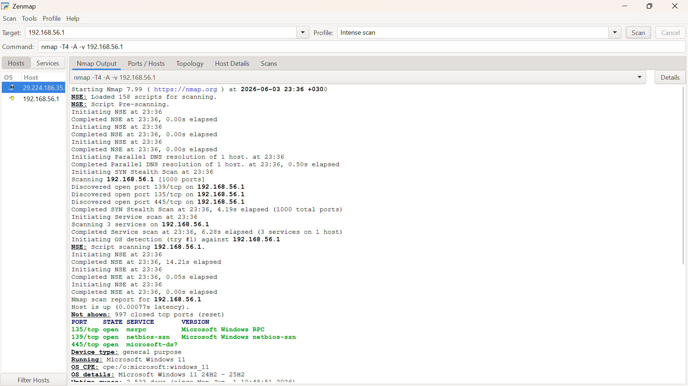
Fig 11: The Zenmap intense scan of your local 192.168.56.1 machine showing Windows 11 and ports 139/445
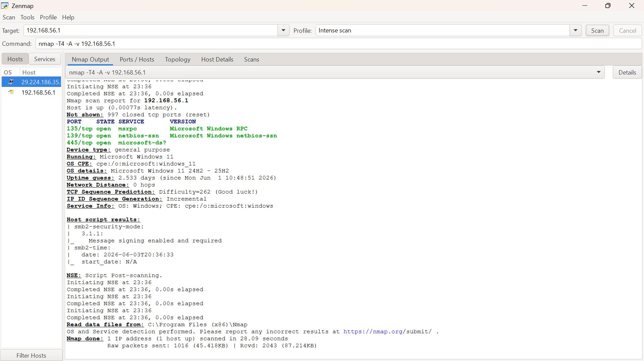
Fig 12: The Zenmap intense scan of your local 192.168.56.1 machine showing Windows 11 and ports 139/445

Sub-Domain
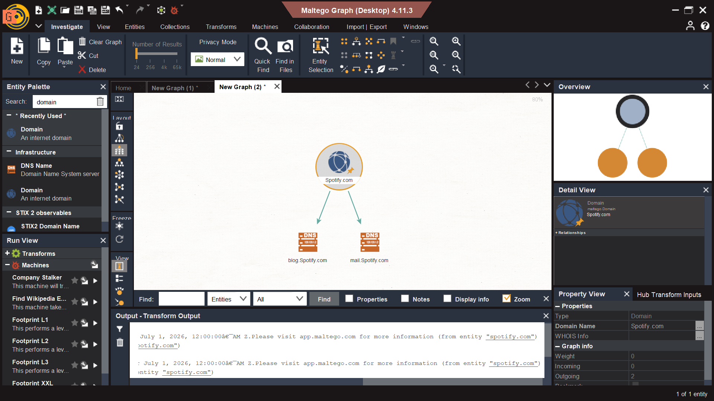
Fig 13: Maltego infrastructure and subdomain mapping

Gaining access

SQL injection Test

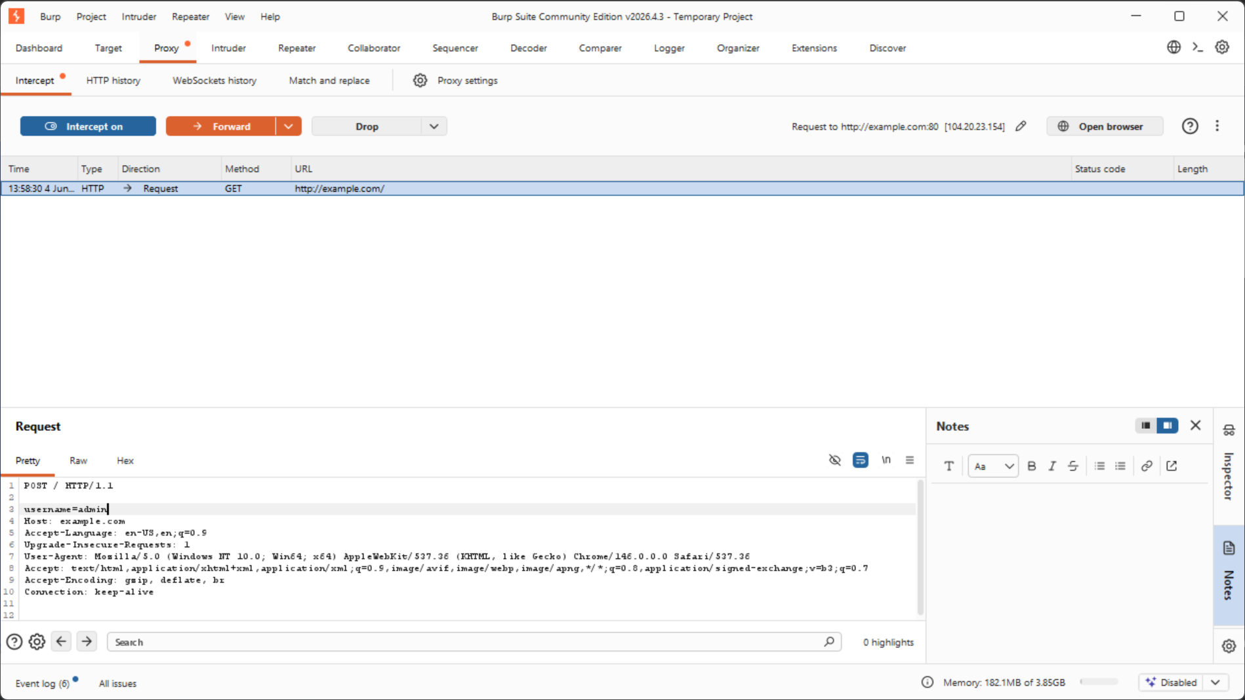
Fig 14: Sql injection using burp suite

